**ER Diagram:**

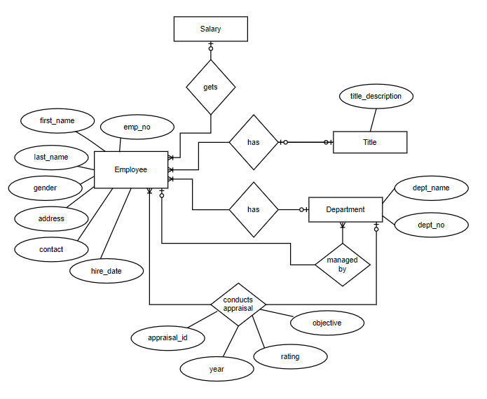

**Table Structure:**

Employees Table

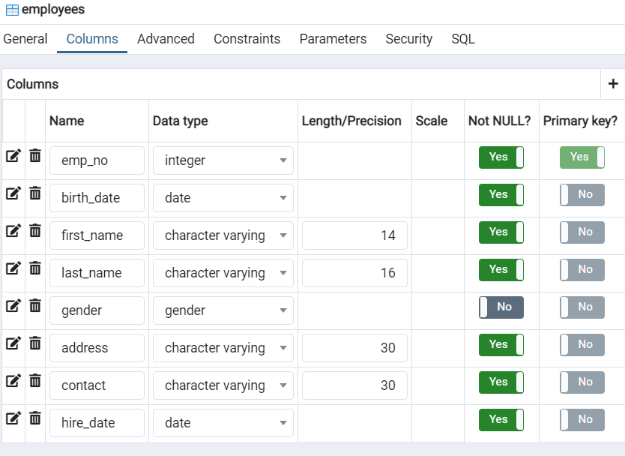

Departments Table

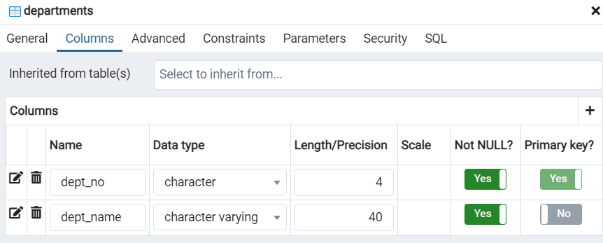

Department and Employee relation table

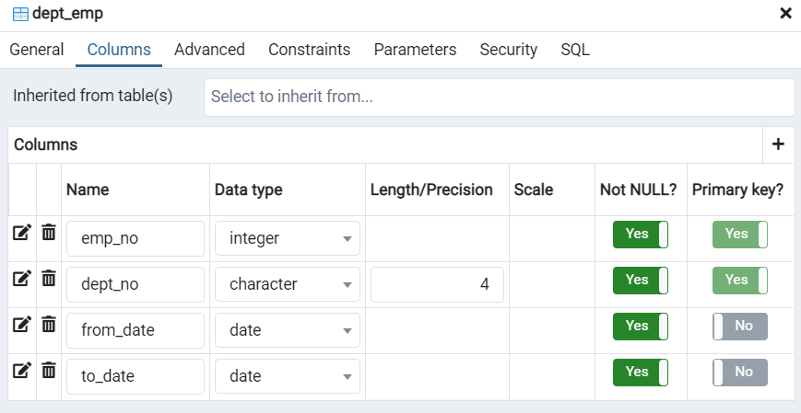

Department and Manager relation table

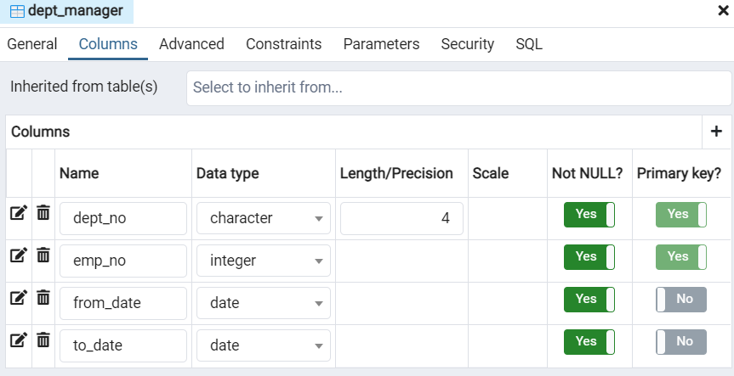

Titles table

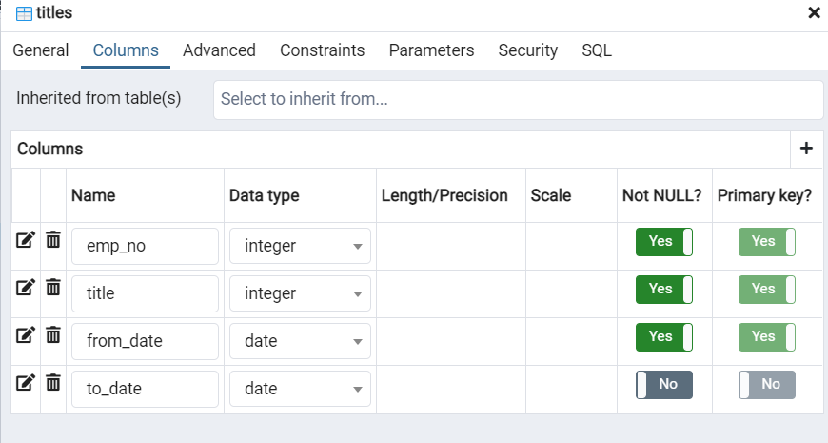

Title Description table

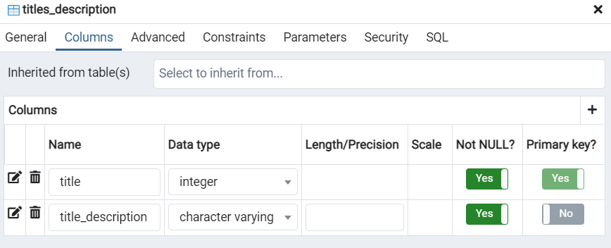

Salary Table

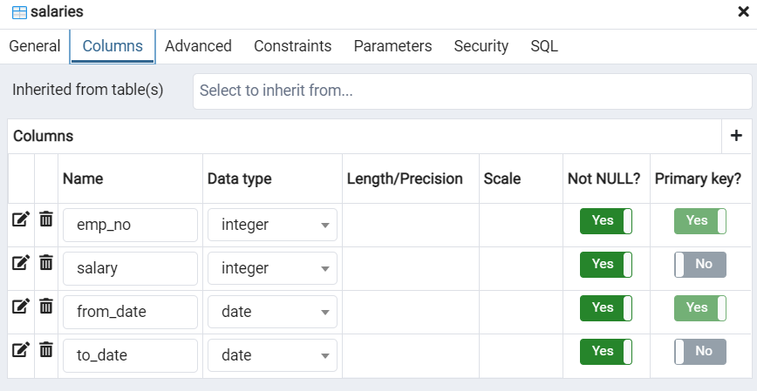

Rating Table

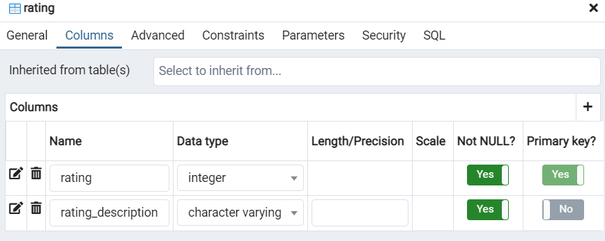

Objective Table

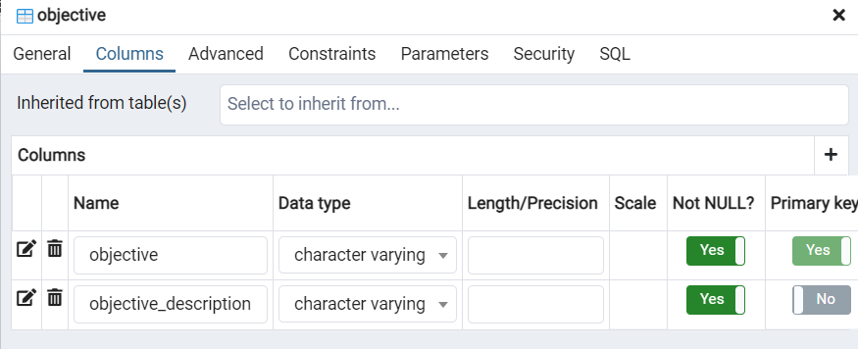

Appraisal Table

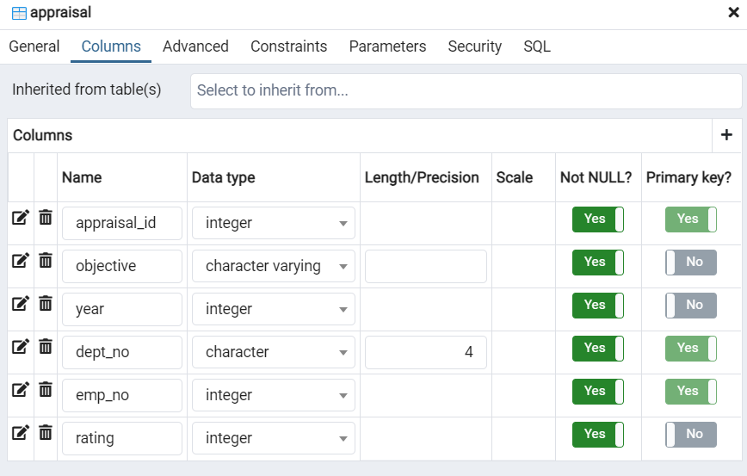

**Create Table Queries:**

Employees Table

CREATE TABLE public.employees

(

emp_no integer NOT NULL,

birth_date date NOT NULL,

first_name character varying(14) COLLATE pg_catalog."default" NOT NULL,

last_name character varying(16) COLLATE pg_catalog."default" NOT NULL,

gender gender,

address character varying(30) COLLATE pg_catalog."default" NOT NULL,

contact character varying(30) COLLATE pg_catalog."default" NOT NULL,

hire_date date NOT NULL,

CONSTRAINT employees_pkey PRIMARY KEY (emp_no)

)

Departments Table

CREATE TABLE public.departments

(

dept_no character(4) COLLATE pg_catalog."default" NOT NULL,

dept_name character varying(40) COLLATE pg_catalog."default" NOT NULL,

CONSTRAINT departments_pkey PRIMARY KEY (dept_no),

CONSTRAINT departments_dept_name_key UNIQUE (dept_name)

)

Department and Employee Relation Table

CREATE TABLE public.dept_emp

(

emp_no integer NOT NULL,

dept_no character(4) COLLATE pg_catalog."default" NOT NULL,

from_date date NOT NULL,

to_date date NOT NULL,

CONSTRAINT dept_emp_pkey PRIMARY KEY (emp_no, dept_no),

CONSTRAINT dept_emp_dept_no_fkey FOREIGN KEY (dept_no)

REFERENCES public.departments (dept_no) MATCH SIMPLE

ON UPDATE NO ACTION

ON DELETE CASCADE,

CONSTRAINT dept_emp_emp_no_fkey FOREIGN KEY (emp_no)

REFERENCES public.employees (emp_no) MATCH SIMPLE

ON UPDATE NO ACTION

ON DELETE CASCADE

)

Department and Manager Relation Table

CREATE TABLE public.dept_manager

(

dept_no character(4) COLLATE pg_catalog."default" NOT NULL,

emp_no integer NOT NULL,

from_date date NOT NULL,

to_date date NOT NULL,

CONSTRAINT dept_manager_pkey PRIMARY KEY (emp_no, dept_no),

CONSTRAINT dept_manager_dept_no_fkey FOREIGN KEY (dept_no)

REFERENCES public.departments (dept_no) MATCH SIMPLE

ON UPDATE NO ACTION

ON DELETE CASCADE,

CONSTRAINT dept_manager_emp_no_fkey FOREIGN KEY (emp_no)

REFERENCES public.employees (emp_no) MATCH SIMPLE

ON UPDATE NO ACTION

ON DELETE CASCADE

)

Titles Table

CREATE TABLE public.titles

(

emp_no integer NOT NULL,

title integer NOT NULL,

from_date date NOT NULL,

to_date date,

CONSTRAINT titles_pkey PRIMARY KEY (emp_no, title, from_date),

CONSTRAINT titles_emp_no_fkey FOREIGN KEY (emp_no)

REFERENCES public.employees (emp_no) MATCH SIMPLE

ON UPDATE NO ACTION

ON DELETE CASCADE,

CONSTRAINT titles_title_fkey FOREIGN KEY (title)

REFERENCES public.titles_description (title) MATCH SIMPLE

ON UPDATE NO ACTION

ON DELETE CASCADE

)

Title Description Table

CREATE TABLE public.titles_description

(

title integer NOT NULL,

title_description character varying COLLATE pg_catalog."default" NOT NULL,

CONSTRAINT titles_description_pkey PRIMARY KEY (title)

)

Salary Table

CREATE TABLE public.salaries

(

emp_no integer NOT NULL,

salary integer NOT NULL,

from_date date NOT NULL,

to_date date NOT NULL,

CONSTRAINT salaries_pkey PRIMARY KEY (emp_no, from_date),

CONSTRAINT salaries_emp_no_fkey FOREIGN KEY (emp_no)

REFERENCES public.employees (emp_no) MATCH SIMPLE

ON UPDATE NO ACTION

ON DELETE CASCADE

)

Rating Table

CREATE TABLE public.rating

(

rating integer NOT NULL,

rating_description character varying COLLATE pg_catalog."default" NOT NULL,

CONSTRAINT rating_pkey PRIMARY KEY (rating)

)

Objective Table

CREATE TABLE public.objective

(

objective character varying COLLATE pg_catalog."default" NOT NULL,

objective_description character varying COLLATE pg_catalog."default" NOT NULL,

CONSTRAINT objective_pkey PRIMARY KEY (objective)

)

Appraisal Table

CREATE TABLE public.appraisal

(

appraisal_id integer NOT NULL,

objective character varying COLLATE pg_catalog."default" NOT NULL,

year integer NOT NULL,

dept_no character(4) COLLATE pg_catalog."default" NOT NULL,

emp_no integer NOT NULL,

rating integer NOT NULL,

CONSTRAINT appraisal_pkey PRIMARY KEY (emp_no, dept_no, appraisal_id),

CONSTRAINT appraisal_dept_no_fkey FOREIGN KEY (dept_no)

REFERENCES public.departments (dept_no) MATCH SIMPLE

ON UPDATE NO ACTION

ON DELETE CASCADE,

CONSTRAINT appraisal_emp_no_fkey FOREIGN KEY (emp_no)

REFERENCES public.employees (emp_no) MATCH SIMPLE

ON UPDATE NO ACTION

ON DELETE CASCADE,

CONSTRAINT appraisal_fk_dep_no FOREIGN KEY (dept_no)

REFERENCES public.departments (dept_no) MATCH SIMPLE

ON UPDATE CASCADE

ON DELETE NO ACTION,

CONSTRAINT appraisal_fk_emp_no FOREIGN KEY (emp_no)

REFERENCES public.employees (emp_no) MATCH SIMPLE

ON UPDATE NO ACTION

ON DELETE NO ACTION,

CONSTRAINT appraisal_objective_fkey FOREIGN KEY (objective)

REFERENCES public.objective (objective) MATCH SIMPLE

ON UPDATE NO ACTION

ON DELETE CASCADE,

CONSTRAINT appraisal_rating_fkey FOREIGN KEY (rating)

REFERENCES public.rating (rating) MATCH SIMPLE

ON UPDATE NO ACTION

ON DELETE CASCADE

)

**Note:** *For SQL used, please refer to the Text file provided.*

**Select Statements:**

/* Select query for fetching all employees managed by a particular manager */

select emp.first_name, emp.last_name, d.dept_name from public.employees emp

inner join public.dept_emp de on emp.emp_no = de.emp_no

inner join public.departments d on d.dept_no = de.dept_no

where de.dept_no in

(select dm.dept_no from public.dept_manager dm

inner join public.employees empl on empl.emp_no = dm.emp_no where empl.first_name = 'Duangkaew')

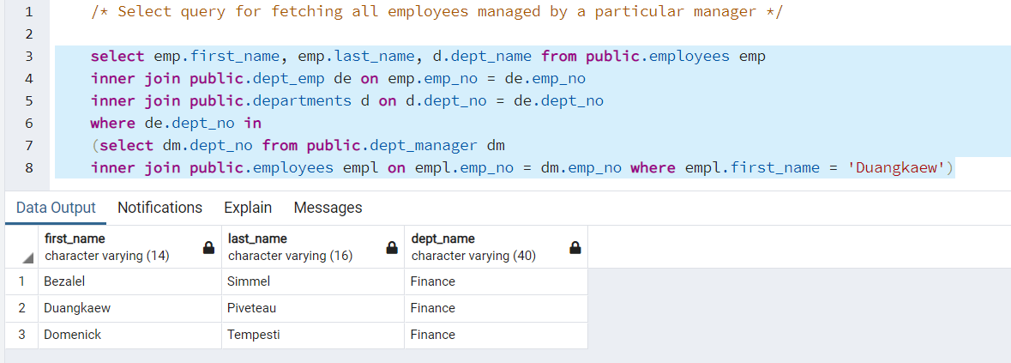

/* Select query for fetching all employees with top rating for the year 2020 */

select emp.first_name, emp.last_name, d.dept_name from public.employees emp

inner join public.dept_emp de on emp.emp_no = de.emp_no

inner join public.departments d on d.dept_no = de.dept_no

inner join public.appraisal app on app.emp_no = emp.emp_no

where app.rating = 1 and app.year = 2020

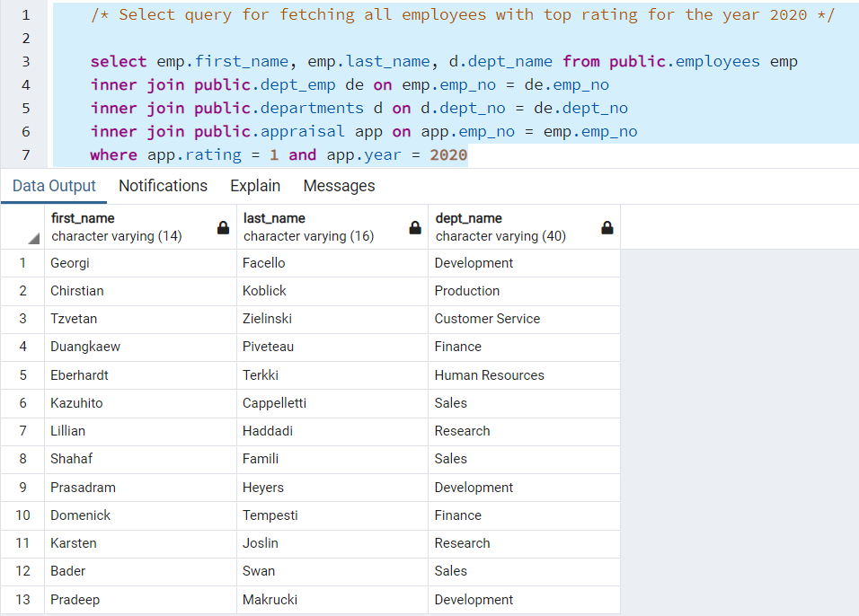

/* Select query for fetching all employees who are hired into the company after a particular date */

select emp.first_name, emp.last_name, d.dept_name,emp.hire_date from public.employees emp

inner join public.dept_emp de on emp.emp_no = de.emp_no

inner join public.departments d on d.dept_no = de.dept_no

where emp.hire_date >= '1995-01-01'

group by emp.first_name, emp.last_name, d.dept_name,emp.hire_date

order by emp.hire_date desc

**Note:** *I have used 1st Jan 1995 instead of 1st Jan 2020*

